SECTION –A

1. b. [a]-GnRH [b]-LH/FSH [c]-estrogen or a. 3 germ layers progestrone [d]-uterus
2. d
b. Inheritamnce of a condition like phenylketouria as an autosomal recessive trait.
3. b. Directional
4. a. Cannabinoids - cardiovascular system

5. b. [a]-(i), [b]-(iii), [c]-(ii), [d]-(v), [e]-(iv)

SECTION-B
6. Components of egg apparatus: one egg cell and two synergids.
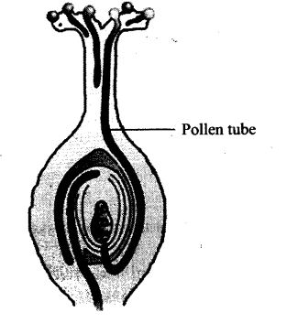 or
Encysted Amoeba divides by multiple fission / produces amoeba or pseudopodiospores /cyst wall bursts out/spores are liberated to grow as amoebae(sporulation)

7. Difference Between Euchromatin And Heterochromatin
Properties | Euchromatin | Heterochromatin
Form | A loosely packed form of DNA | A tightly packed form of DNA
Heteropycnosis | Does not exhibit | Exhibits
DNA density | Low | High
Found | Prokaryotes as well as eukaryotes | Eukaryotes only
State | Active | Inactive
Replication | Early replicative | Late replicative
Sticky/Non-sticky | Regions are not sticky | Sticky regions
Presence | Inner body of the nucleus | The periphery of the nucleus
Activity | No or little transcriptional activity | Participate in the transcriptional activity

8. Between the two amino acids bound to the two sites of the large sub units of bacterial ribosomes, when two charged tRNAs are brought close enough peptide bond is formed with the help of ribozyme.
9. In most of the angiosperms, pollen grains released at 2-celled stage. Pollen grain contains a small generative and a large vegetative cell. At 3-celled stage pollen grains contains one vegetative cell and two male gametes are present.

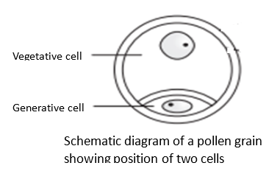
10. Haemophilia is a sex - linked trait caused by a recessive gene located in the X chromosome. Thalassaemia occurs when there is an abnormality or mutation in one of the genes involved in haemoglobin production. People with haemophilia have either defective clotting factors or lack clotting factors, whereas people with thalassaemia have either abnormal haemoglobin or lack haemoglobin in their red blood cells. Haemophilia is a sex-linked disorder, but thalassaemia is an autosomal disorder.
11. a. MOET is a programme for herd improvement to get more eggs. The genetic mother is available for another round of super ovulation in this technology.
b. The primary aim of ART is to help the infertile couple in having offspring by retrieving oocytes from the ovary or sperms from the testes, bringing about artificial insemination and development of embryo.
12. A is more reactive
2'-OH group present in the pentose sugar
Makes it more labile/ catalytic and easily degradable.
13. a) The patient is suffering from Acquired Immuno Deficiency Syndrome.
b) Human Immuno Virus is the causative organism.
c) Helper cells or T4T4 Lymphocytes are the cells of the body are affected by the pathogen.
14. The gain or loss of chromosomes from the normal 46 is called as aneuploidy.
Explanation:
Down syndrome in which a person has three copies of chromosomes 21 in each i.e total 47 chromosomes.
Monosomy or loss of chromosomes is the another type of aneuploidy.
15. In some species, the diploid egg cell is formed without reduction division and develops into the embryo without fertilization.
In many Citrus and Mango varieties some of the nucellar cells surrounding the embryo sac start dividing, protrudes into the embryo sac and develops into the embryos. In such species each ovule contains many embryos.
16. (i) When Natural Selection is disruptional (ii) Recombination (during gametogenesis); gene flow; genetic drift; mutation
17. (a) After implantation, the chorionic villi that appear on trophoblast, interdigiate with the uterine tissue, jointly form placenta.
(b) Estrogen, progestogens.
18. Lactose / inducer binds with repressor protein, inactivates it, frees operator gene, RNA Polymerase freely move over structural genes / RNA polymerase access to the promoter, transcribing to, lac mRNA, which on translation, produce transacetylase, permease, β-galactosidase.
19. a. (1) Characters are controlled by discrete unit called factors or genes.
(2). Factors occur in pair.
(3) In a dissimilar pair of factors one member of the pair dominates/only one of the parental character is expressed in a monohybrid cross in the ${{F}{1}}$ and both are expressed in the
${{F}{2}}$.
b.Due to non-functional enzyme / less efficient enzyme / non-enzyme at all.
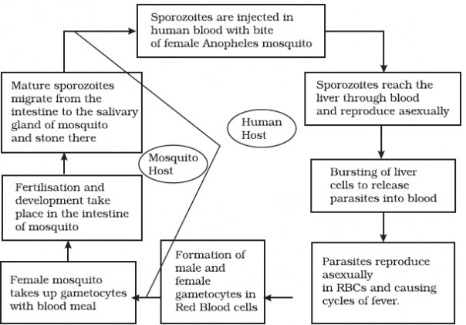
20.

21. i) A polypeptide containing 14 different amino acid = 14x3=42 base pairs.
ii) 14 different types of RNA are needed for the synthesis of polypeptide.
22. i. UUU ii. GUG iii. AAA iv. CAC
23. Cross A, because they are tightly linked / due to close physical association / they are closely located.
24. Chemical evolution – First form of life originated from pre-existing non-living organic molecules.
b.) Amino acids
c.) H2
25. (a)1.Diploid egg cell is formed without reduction division and develops into embryo without fertilization e.g., grasses.
2.In citrus/mango, some of the diploid nucellar cells surrounding the embryo sac start dividing, protrude into embryo sac & develop into a embryo.
(b)No degregation in hybrid seeds, economically beneficial/desired varietes are cultivated.
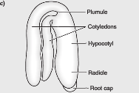
25.a. Differences between Darwin’s concept and de Vries concept:
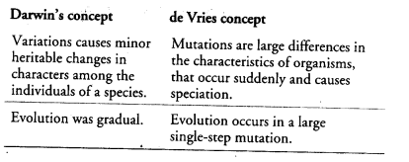
b. Certain factors that affect Hardy-Weinberg equilibrium and leads to evolution are as follow:
(i)Gene Migration or Gene Flow
New genes or alleles are added to new population and are lost from old population inturn changing the gene frequencies. This is called gene migration. When gene migration happens multiple times, it is called gene flow.
(ii)Genetic Drift
It refers to a random gene frequency change and occurs only by chance. At times, the change in allele frequency is so different in the new sample of population that they become a different species. '
The original drifted population becomes the founder and the effect is called founder effect.
(iii)Mutation
The sudden change in appearance or variations in an individual or a population are called mutations. They lead to the new phenotypes.
Though mutations are random and occur at very slow rates, they are sufficient to create considerable genetic variations for speciation to occur.
(iv)Genetic Recombination
When the alleles of parental linkage groups separate and new associations of alleles are formed due to crossing over during gametogenesis. This process is known as genetic recombination.
c. According to De-Vries, saltation is a single step large mutation that leads to speciation.
26. Polygenic inheritance 1 Mark
• If we assume skin colour is controlled by three genes A, B, C
• Dominant forms (A,B,C) are responsible for dark skin colour and recessive form (a, b, c) for light skin colour 1 Mark
• The genotype with all dominant alleles (AABBCC) will be darkest skin colour and with recessive alleles will be light test skin colour (aabbcc) (1+1=2 Marks) 5
5 • The genotypes (AaBbCc) will be of intermediate skin colour i.e. with three dominant alleles and three recessive alleles 1 Mark

27. 